GROUP 3 ASSIGNMENT 5
1.SSENYONJO TREVOR BU/UP/2025/05769
2.NAKAKANDE RACHAEL BU/UP/2025/05767
3.LYKA AMELIA KIRABO BU/UP/2025/05765
4. HENRY HANNINGTON DRICHI BU/UP/2025/4963
5.ONANA ATWANZIRE VICTOR BU/UP/2025/5176

This assignment covers the theoretical foundation, algorithm design (pseudocode & flowcharts), and programmatic implementation for three core numerical algorithms:
- Secant Method (Root Finding)
- Newton-Raphson Method (Root Finding)
- Runge-Kutta 4th Order Method (RK4) (Numerical Solution of Differential Equations)

  - SECANT METHOD
Find the root of $f\left(x\right)= x^{3}-x-2$ with initial guesses${ x}_{0}=1.0 and x_{1}=2.0,$target tolerance $∈ = {10}^{-4}$
PSEUDO-CODE
$$Input x_{0 },x_{1} ,tol,max⁡_iter$$
$$iter=0$$
$$while iteration<max⁡_iter,DO$$
$$f(x_{0})= {(x}_{0}^{3}-x_{0}-2)$$
$f\left(x_{1})=(x_{1}^{3}-x_{1}-2\right)$
$If \left[f\left(x_{0}\right)- f\left(x_{1}\right)\right]<1e-12 ,Then$
$Print "Error: Division by near-zero"$
$Break$
$End if$
$$x_{2}=x_{0}- \frac{{f(x}_{1})-(x_{1}-x_{0})}{f\left(x_{1}\right)-f(x_{0})}$$
$$If \left|x_{2}-x_{1}\right|<tol, Then$$
$$Print "Root found: ",x_{2}$$
$$Break$$
$$End If x_{0} = x1$$
$$x_{1}= x_{2}$$
$$iter = iter + 1$$
$$End While$$

FLOWCHART DESCRIPTION
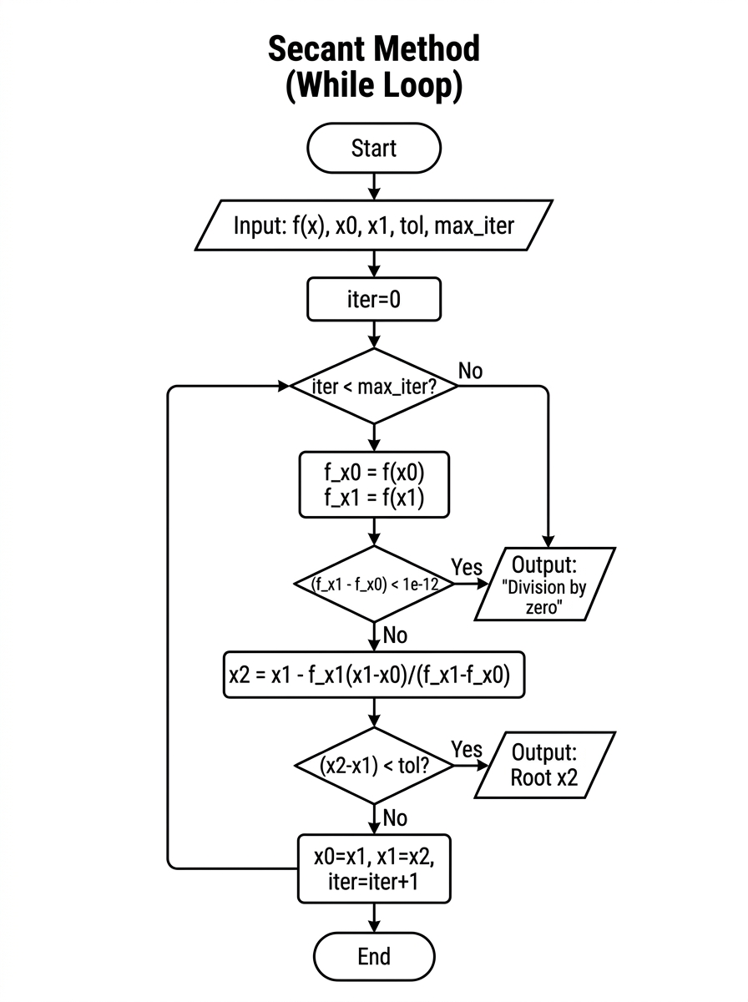
Implementing using while loop
Newton-Raphson Method using WHILE loop
f = @(x) x^2 - 5;
df = @(x) 2*x;

x0 = 2.0;
tol = 0.0001;
max_iter = 100;

iter = 0;
diff = tol + 1;

fprintf ('Iter\t x1\t\t f(x1) \n');
fprintf('----------------------------------\n');

while diff >= tol && iter < max_iter
f_val = f(x0);
df_val = df(x0);

Secant Method using a FOR loop
f = @(x) x^3 - x - 2;

x0 = 1.0;
x1 = 2.0;
n_steps = 10;

fprintf ('Iter\t x2\t\t f(x2) \n');
fprintf('----------------------------------\n');

for iter = 1: n_steps
f0 = f(x0);
f1 = f(x1);

x2 = x1 - f1 * (x1 - x0) / (f1 - f0);
fprintf ('%d\t%f\t%f\n', iter, x2, f(x2));

x0 = x1;
x1 = x2;
end

fprintf ('\nRoot after %d iterations: %.6f\n', n_steps, x2);

if abs(df_val) < 1e-12
error ('Derivative is too close to zero.');
end

x1 = x0 - (f_val / df_val);
diff = abs (x1 - x0);

iter = iter + 1;
fprintf ('%d\t%f\t%f\n', iter, x1, f(x1));

x0 = x1;
end

fprintf ('\nApproximate Root: %.6f\n', x1);

2. NEWTON-RAPHSON METHOD
Find the root of $f\left(x\right)= x^{3}-5(computing 5)$ with initial guesses${ x}_{0}=2.0 and$ tolerance $∈ = {10}^{-4}$
PSEUDOCODE
INPUT x0, tol, max_iter
iter = 0
WHILE iter < max_iter DO:
fx = x0^2 - 5
dfx = 2 * x0
IF |dfx| < 1e-12 THEN
PRINT "Derivative near zero"
BREAK
END IF
x1 = x0 - (fx / dfx)
IF |x1 - x0| < tol THEN
PRINT "Root found: ", x1
BREAK
END IF
x0 = x1
iter = iter + 1
END WHILE

FLOWCHART DESCRIPTION

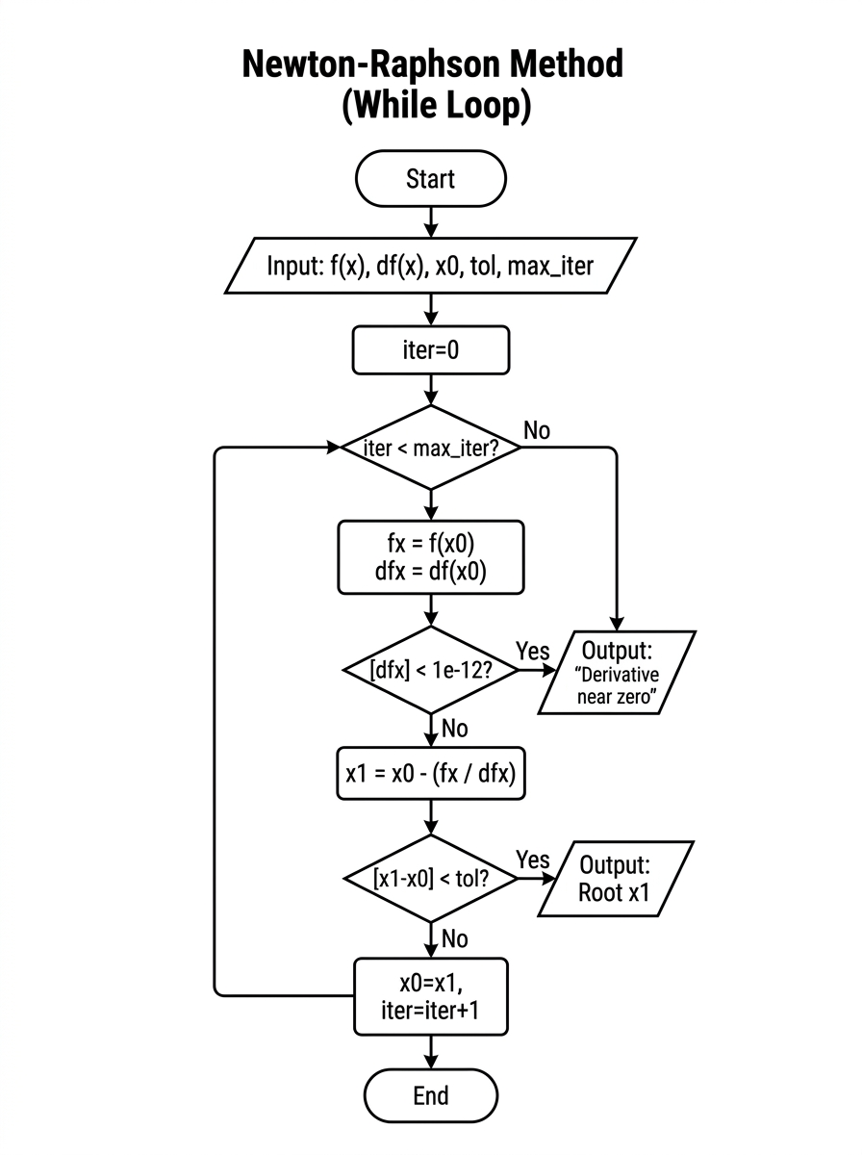

Newton-Raphson Method using a WHILE loop
f = @(x) x^2 - 5;
df = @(x) 2*x;
x0 = 2.0;
tol = 0.0001;
max_iter = 100;
iter = 0;
diff = tol + 1;
fprintf ('Iter\t x1\t\t f(x1)\n');
fprintf('----------------------------------\n');
while diff >= tol && iter < max_iter
f_val = f(x0);
df_val = df(x0);
if abs(df_val) < 1e-12
error ('Derivative is too close to zero.');
end
x1 = x0 - (f_val / df_val);
diff = abs (x1 - x0);
iter = iter + 1;
fprintf ('%d\t%f\t%f\n', iter, x1, f(x1));
x0 = x1;
end
fprintf ('\nApproximate Root: %.6f\n', x1);
Newton-Raphson Method using a FOR loop
f = @(x) x^2 - 5;
df = @(x) 2*x;
x0 = 2.0;
n_steps = 6;
fprintf ('Iter\t x1\t\t f(x1)\n');
fprintf('----------------------------------\n');
for iter = 1: n_steps
x1 = x0 - (f(x0) / df(x0));
fprintf('%d\t%f\t%f\n', iter, x1, f(x1));
x0 = x1;
end
fprintf ('\nRoot after %d iterations: %.6f\n', n_steps, x1);

3.RUNGE-KUTTA 4TH ORDER (RK4) METHOD
Solve the initial value problem$\frac{dy}{dx}=x+y$ with y(0) = 1, step size h = 0.1, to approximate y(0.5).
PSEUDOCODE (for the for loop)
INPUT x0, y0, x_target, h
n_steps = (x_target - x0) / h
x = x0
y = y0

FOR i = 1 TO n_steps DO:
k1 = h * f (x, y)
k2 = h * f (x + h/2, y + k1/2)
k3 = h * f(x + h/2, y + k2/2)
k4 = h * f (x + h, y + k3)

y = y + (k1 + 2*k2 + 2*k3 + k4) / 6
x = x + h
PRINT x, y
END FOR

FLOWCHART DESCRIPTION
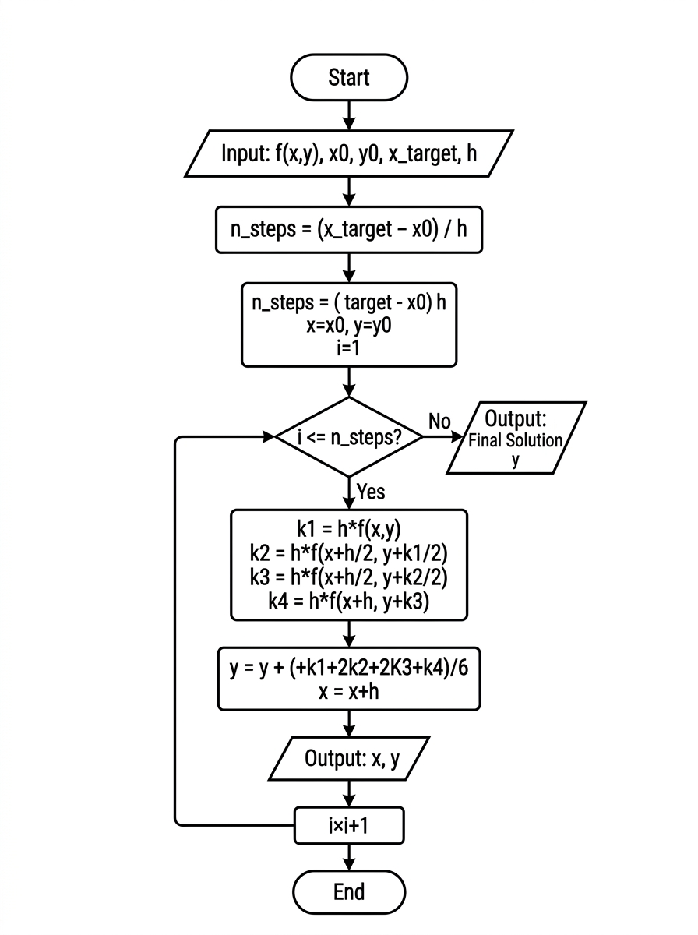

RK4 Method using a WHILE loop
f = @(x, y) x + y;

x0 = 0;
y0 = 1;
x_end = 0.5;
h = 0.1;

x = x0;
y = y0;
step = 0;

fprintf ('Step\t x\t\t y\n');
fprintf('----------------------------------\n');
fprintf ('0\t%f\t%f\n', x, y);

while x < x_end
% Ensure last step fits exact boundary
if (x + h) > x_end
h = x_end - x;
end

k1 = h * f(x, y);
k2 = h * f(x + h/2, y + k1/2);
k3 = h * f(x + h/2, y + k2/2);
k4 = h * f(x + h, y + k3);

y = y + (k1 + 2*k2 + 2*k3 + k4)/6;
x = x + h;
step = step + 1;

fprintf ('%d\t%f\t%f\n', step, x, y);
end

fprintf ('\nFinal Solution at x = %.2f is y = %.6f\n', x_end, y);

